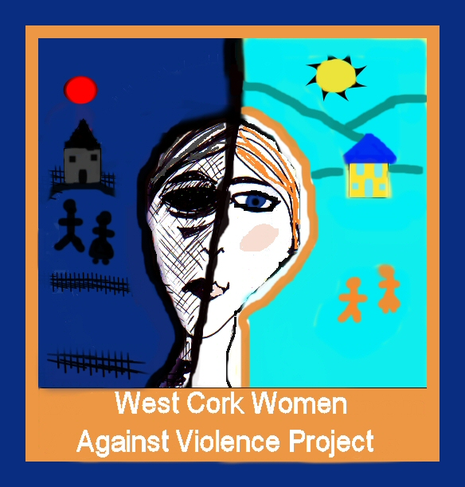

- PERSONAL DETAILS (use BLOCK LETTERS)

Surname | First Name
Permanent Address | Address for Correspondence (if different)
Preferred Telephone number (Home) (Mobile)
email address

- REFEREES

In the event of a job (not interview) offer, would you be willing to give your permission to contact this person for a reference? Yes No

Give name, address and a contact number of two persons not related to you who are willing to supply a reference. One of these should be your current or most recent employer
Employer Referee (1) | Referee (2)

DECLARATION
I certify that the information given in this application is accurate and complete to the best of my knowledge.

Signed: ____________________________________ Date: _________________

Please note that the signing of this application form indicates that you have read the job description and any other information issued by the Company and that you can comply with the requirements of the post. Any false statements could result in the application being declared invalid.
This application form, when completed, should be returned by email to admin@westcorkwomensproject.ie OR by post to West Cork Women Against Violence, Wolfe Tone Square, Bantry, Co. Cork.

Closing date and time for receipt of application: Friday 24th February 2023 at 1pm.
Late or incomplete applications will not be accepted.

Please use as much as space as you need to complete the questions and give full answers.

- EDUCATIONAL QUALIFICATIONS

Title of Award | University/College/School | Dates of Study | Final Examination Subjects and Results
Other training undertaken, either privately or through previous employments

4. INFORMATION TECHNOLOGY – please tick boxes below as appropriate

 | No knowledge | Limited familiarity | Extensive use in work | Qualification Award
Microsoft Word
Microsoft Excel
Microsoft Outlook
Database / Statistical Analysis software (please specify)

Other (please specify)
Please give examples of the use you have made of the internet to support/enhance your work in previous employments

5. PROFESSIONAL MEMBERSHIPS / ASSOCIATIONS (if any)

6. EMPLOYMENT HISTORY

Dates (from-to) | Employer Name & Address / Nature of Business | Position Held | Reporting To | Main duties and responsibilities; key achievements

7. PLEASE ANSWER THE QUESTIONS BELOW MAKING REFERENCE TO RELEVANT EXPERIENCE GAINED IN YOUR PREVIOUS EMPLOYMENTS, WHERE APPROPRIATE

a) Please give a brief description including dates of your relevant work experience in project management, including staff, budgets, and finances.

b) Describe how through your work experience/education, you have achieved an understanding of the issue of Sexual Violence in Ireland.

c) Give example(s) where you have used your communications skills and/or negotiation skills to good effect in your previous employments | One-to-one communication:  Communication to groups:  Negotiation:
d) Give example (s) from your experience of delivering, high quality, inclusive, client-centred services

f) Describe your experience in working with and building partnerships with other agencies and sectors?

f) Give an example of your experience of strategic development and planning

8. OTHER

Please note any of your professional or personal interests which you consider particularly relevant to the role of SEXUAL VIOLENCE SUPPORT SERVICE PROJECT COORDINATOR for West Cork Women Against Violence project, noting dates of your involvement/membership.

