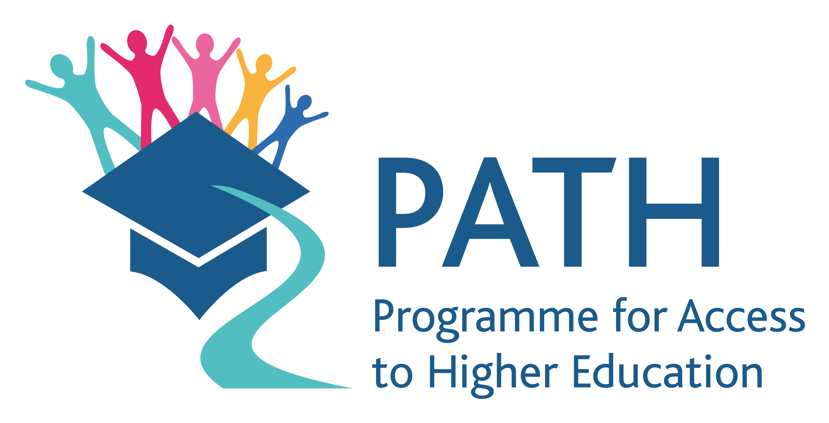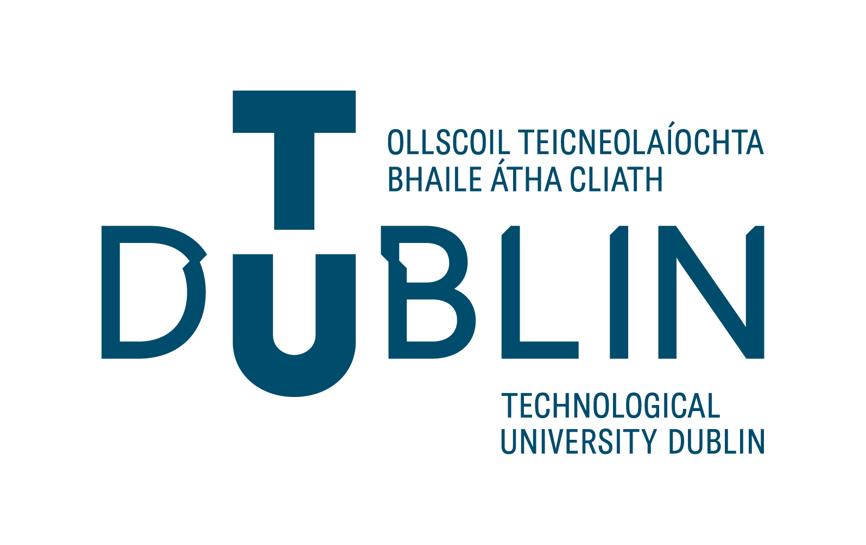
Revised Version
Invitation to tender.

This tender is for a review of approaches and models of partnership working, with a focus on interagency working, particularly partnerships between: Higher Education Institutions, other statutory education providers and community organisations. The work will include a review of consortium and other partnership models, processes, governance & structures that support effective partnership working as well as a review of factors impacting the sustainability of community-higher education partnerships. The aim of the work is to systematically review and capture learning on partnership processes to inform current and future partnership work, as part of the TU Dublin PATH 3 programme.

PATH 3.
The Programme for Access to Higher Education, Strand 3 (PATH 3) is a fund established by the Department of Education and Skills, now the Department of Further and Higher Education, Research, Innovation and Science, in 2017 as a commitment to support the National Plan for Equity of Access to Higher Education 2022-2028.

The focus of strand 3 is to support ‘the development of regional and community partnership strategies to increase access to higher education by underrepresented groups. It is intended that higher education institutions will form effective partnerships within their clusters and engage with local DEIS schools, further education providers, community and voluntary groups and other relevant stakeholders’. https://hea.ie/policy/access-policy/path/

TU DUBLIN PATH 3.
The TU Dublin PATH 3 project is a programme of work across TU Dublin and with the three communities adjacent to each of the TU Dublin campuses. The aim is to work collaboratively with local community partners including local DEIS schools, community groups and other statutory education partners to devise and implement activities to support engagement and progression to Higher Education among disadvantaged communities.

AIM OF TENDER
The aim of the project which we invite you to tender for is to complete a review of models, structures, processes and existing best practices that support the development and sustainability of partnerships and interagency working between Community organisations and Higher Education Institutions (HEIs). In the context of the review, community organisations refer to:
- Early Childhood Organisations.
- Primary schools and 2nd level schools.
- Further Education and training sector organisations.
- Adult Education Organisations.
- Community groups including social enterprises, NGO’s, and community and voluntary sector organisations.
- Other public sector agencies (including LCDC, Local Authority, Local Development Partnerships).
The outcomes of the review will contribute to a series of seminars exploring partnership working and will support PATH 3 and other community-higher education partnerships.

KEY DELIVERABLES.
The Consultant will deliver a report on partnership working based on:
- Comprehensive desk review of published national and international reports.
- Qualitative interviews with representative staff from a range of Community and Education sectors currently involved in a different types of partnership working. It will also include case studies with learners, including their experience of interagency working and how it impacts the learner experience.
- Final report incorporating results of point 1 & 2.

Timeline | Deliverable
Mar 2023- May 2023 | Interim desk review completed. Production of a draft report on themes related to partnership working (see further detail below). This will include an annotated, themed, catalogued list of open access resources on partnership working.
June 2023 – July 2023 | Qualitative interviews conducted with:  - key senior leaders from Community and Education sectors who involved in partnership work.  - Sample of learners who have experienced interagency working
Sept 2023 | Submission of final report incorporating desk review and qualitative interview data by end of September.

DETAILED OUTLINE OF DELIVERABLES:

Output | Details
Report chapter: Community- HEI partnership models. | - Categorisation of the range of possible HEI-Community partnerships based on type and purpose of the partnership.  - Evidence-based evaluation and comparison of different partnership models in different contexts. This will include a review of models that support partnerships of different size and purpose.  - The evaluation will also cite both national (where available) and international examples of each type of partnership model.
Report chapter: Structures to support effective partnership. | Evidence-based review of:  - Governance structures within different community-HEI partnerships and synthesis of the pros and cons of each, for a range of different partnership sizes and purposes.  - Partnership Meeting Structures: Comparison of a range of possible meeting structures to best support partnership working based on type and purpose of partnership.  - Partnership and Consortium Agreements: evidence-based review of types, examples and best practices in the development of consortium and partnership agreements depending on type and purpose of partnership.  - Service Level Agreements: Review and evaluation of the role of Service Level Agreements in community- HEI partnerships. This should be evaluated in light of the range and purpose of different types of partnerships and will include best practice examples for different contexts and synthesis of the pros and cons of each.
Report Chapter: Building and maintaining relationships in partnership work. | Evidence-based review of:  Processes that support relationship building in community- Higher Education partnerships, and best practices that are suitable in light of the range of possible purposes and types of Community-Higher Education partnerships.
Report chapter:  Resourcing frameworks & staff skills to support partnership working. | Evidenced-based review of:  - Resourcing and budget frameworks to support collaborative working between community and Higher Education partners: Best practices and examples in different types of partnership resourcing models.  - Evidence-based review of staff skills needed to support partnership work.
Report chapter:  Sustainability in Community-Education Partnerships. | Evidence-based review of:  - Structures & processes that support sustainability of community-HEI partnerships.  - Review and evaluation of examples of national and international community-HEI partnerships, including the process of developing sustainable initiatives.  - Best practices and process of interlinking evaluation, impact & sustainability.

- BUDGET
Budget: The budget for this project up to a maximum of €15,000. Applicants are expected to accurately price the work involved.

Timeframe: Research work is expected to take place from March to September 2023. Final report to be submitted at the end of September 2023.

CRITERIA FOR ASSESSMENT

7.1 Contract Award
The basis for contract award under this Competition is the most economically advantageous proposal determined using the following criteria and weighting:

Criteria | Maximum Score Available | Minimum Score Required
Relevant experience/ track record of successfully delivering similar work | 40% | 16%
Quality of Plan | 30% | 12%
Cost | 20% | 8%
Structures, policies and practices in place to ensure ethical and excellent data collection, management and protection, in line with TU Dublin data protection requirements. | 10% | 4%
Total Maximum Score Available | 100% | 40%
NOTE:
- Bidders must achieve the above stated Minimum Score Required in all criteria outlined above.
- Only the top scoring Bidder that complies with the requirements set out in this RFQ will be awarded a contract, subject to the Bidder submitting a valid Tax Clearance Certificate and Certificate of Insurance.
- Bidders are reminded that TU Dublin reserves the right to cancel this competition at any stage prior to a formal Purchase Order being issued.

7.2. Explanation of Award Criteria

- Relevant Experience refers to the availability and relevant expertise of the staff member proposed to deliver the Services, particularly in terms of their experience and understanding of Higher Education Institution-Community partnerships, including governance, evaluation and experience working in partnership with a range of organisations and sectors including community organisations and larger statutory bodies. The availability of proposed resources to deliver the services will also be assessed and confirmation of the ability of the supplier to provide the services for the duration of the project is required.
Relevant experience will be assessed using cover letter, CV(s) and references. Bidders are also asked to submit an example of a previous evaluation completed.
- Quality of Plan refers to the quality of the proposed plan and method the bidder proposes to deliver the services (maximum of 2 A4 pages). Quotations will be evaluated in terms of the extent to which they demonstrate their ability to meet the stated requirements of TU Dublin.
- Cost means the daily rate quoted inclusive of all fees, charges and expenses (if any) associated with the delivery of the Services and exclusive of VAT. The Bidder with the lowest cost shall be awarded the maximum score available under this criterion.

REQUIREMENTS OF THE TENDER WINNER
The successful bidder will produce all the deliverables above on time as agreed with TU Dublin. They will liaise with TU Dublin PATH 3 staff on a regular basis to facilitate smooth delivery of the work.
They will complete a due diligence process and sign a Service Level Agreement (SLA) with TU Dublin which outlines their full responsibilities to the PATH 3 programme. The SLA resulting from this process will run from the date of issue until the work is completed. The work includes reporting on expenditure, process and outcomes.
The successful bidder will also be required to have evidence of their own insurance and a valid tax clearance certificate.
The successful bidder will be required to comply with GDPR, TU Dublin’s data protection policy and adhere to best practices in relation to data processing and management.

FURTHER INFORMATION/QUESTIONS
  - All queries in relation to this tender must be submitted in writing to path3@tudublin.ie no later than February 9th 2023. Queries or requests for clarifications received after this date will not be accepted.

  - In the interests of equity for all bidders, any questions of substance and responses to same will be made available to all interested parties without divulging the identity of the originator.

SUBMISSION DEADLINE

The deadline for receipt of submissions is 17th February 2023. Tenders received after this date will not be considered. Proposals should be emailed to path3@tudublin.ie using the subject ‘PATH 3 Tender: Application attached’. Shortlisted candidates may be called for interview.

TENDER REQUIREMENTS
Tenders should include the following:
- Cover letter highlighting previous relevant experience, particularly experience working with a range of organisations and sectors including community organisations and large statutory bodies. Experience and understanding of Higher Education governance as well as of the community sector is desirable. Bidders should include an example of previous evaluation report completed, similar to the type of work requested in this tender.
- Curriculum Vitae of person(s) applying, including two relevant referees (preferably one referee from higher education and one from a community sector organisation).
- A workplan, including clear milestones and deliverables, and proposed approach to carrying out the work, including a breakdown of days (maximum 2 pages).
- A full budget breakdown including indication of hourly / day rate, and all fees, charges and expenses.
- Where a group or consortium submits a proposal, a lead consultant must be nominated who shall be fully responsible for providing the services required by this brief.

