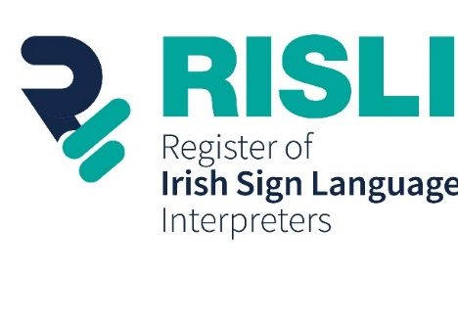
Irish Sign Language Video
Expression of Interest Application Form
Expression of Interest Application Form for board membership of the Regulatory Centre for Irish Sign Language Interpreters Ireland CLG. The company was set up for the purpose of maintaining the Register of Irish Sign Language Interpreters (RISLI). The company operates under the business name of RISLI. The application form can be submitted in Irish Sign Language (ISL) or written English.
Applicant
Title
Name
Address
Telephone number
Email Address
Job/Position
Over 18 years of Age (Please tick) | Yes No

Professional Experience
Please provide relevant information about your knowledge, understanding and professional experience.

Previous Board Member Experience
Please provide information in relation to any Board, Committee and other organisations you were previously involved.

Referees
Please provide contact details of at least two referees RISLI might contact in relation to your Expression of Interest.
Name | Email Address | Phone number
Please submit the Expression of Interest Application Form in ISL/Written English by email to margaret.oconnor@risli.ie
If you wish, you may also submit additional information (such as a C.V. or short Bio) to support your application.
Signed |  | Date

