Recognising and responding to the impacts of domestic abuse on women

About this training
Women’s Aid has developed a half day online training programme focused on recognising and responding to domestic abuse. The training is for anyone who in their professional capacity interacts with survivors of domestic abuse. Training is delivered on Zoom. Each participant must have access to a private space, a good internet connection, a computer, or another device to take part in the training.

Why avail of the Training?
As domestic violence affects 1 in 4 women in Ireland, anyone working with women can encounter domestic violence through their work. The responses a victim/survivor receives when seeking initial support from frontline services can have a major impact on their safety and well-being, and that of their children. Whatever your work role, this training will give you the foundation knowledge to appropriately respond and to link women to support services both locally and nationally.

What will I gain from this training?

The training is framed around the 3 Rs – Recognise, Respond, and Refer.

Recognise | Respond | Refer
• Dynamics of domestic abuse  • Forms and tactics of abuse used by the perpetrator and the intention behind them  • Impacts on the victim/survivor and their coping mechanisms  • Indicators that may alert us a woman is experiencing domestic abuse | • Learn victim-centred principles which should guide your response  • Understand the barriers facing victim/survivors in seeking and accessing support  • Learn how to safely support a disclosure | • Increase knowledge about referral options to specialist domestic abuse services and what they can offer

About Women’s Aid

Women's Aid is a national frontline organisation working to prevent and address the impact of domestic violence and abuse including coercive control, in Ireland since 1974. We do this by advocating, influencing, training, and campaigning for effective responses to reduce the scale and impacts of domestic abuse on women and children in Ireland and providing high quality, specialised, integrated, support services. For more information, please visit: www.womensaid.ie

Important: Please note that the training may not be suitable for anyone currently experiencing, or who has recently experienced, domestic violence as the material may be distressing. If you have any questions or concerns about participating in the training, please feel free to contact us.

The training is designed to upskill those supporting women experiencing domestic violence. If you are a woman experiencing domestic violence, or if you are concerned on behalf of someone else, please contact Women’s Aid 24hr National Freephone Helpline on 1800 341 900.

How to Book Your Place

Please note that we prefer if you can book and pay for a training space on our website. However, if you are unable to book online, you can complete the booking form below and send to the Training Administrator by email: training@womensaid.ie and we will be in touch to confirm your booking. Please note that we can only accommodate three people from one organisation in one training, if you have more than 3 people please contact the Training Administrator by email: training@womensaid.ie.

Women’s Aid is supported by the Scheme to Support National Organisations which is funded by the Government of Ireland through the Department of Rural & Community Development.
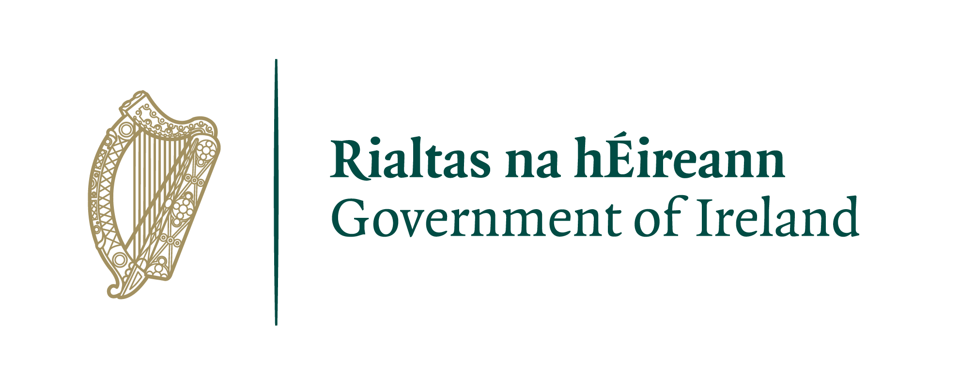

BOOKING FORM

Recognising & responding to the impacts of domestic abuse on women

Half day Online Training

Date of Training: Thursday, 23 February 2023 ☐
Thursday, 27 April 2023 ☐
Wednesday, 21 June 2023 ☐

Online Platform: Zoom
Training fee: €75.00 per person
Time: Registration at 9.45am Training from 10am to 1pm
Name:

Job Title:

Organisation:

Email address:

Phone number:

What do you hope to achieve from attending this training?

Do you have any access requirements? If yes, please outline below.

