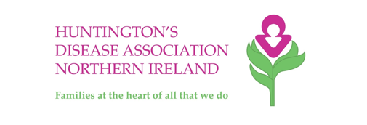

What is Huntingtons Disease?
Huntington's disease is an inherited condition that damages certain nerve cells in the brain.
This brain damage gets progressively worse over time and can affect movement, cognition (perception, awareness, thinking, judgement) and behaviour.
Early features can include personality changes, mood swings, fidgety movements, irritability and altered behaviour, although these are often overlooked and attributed to something else.

Who is Affected?

Both males and females with a family history of Huntington's disease can inherit the condition. The disease carries a 50% risk of inheritance.
Symptoms usually start to appear during adulthood and progress over 5-20 years. Juvenile (children's) Huntington's disease is rarer and develops before the age of 20. In Northern Ireland there are known to be hundreds of people living with the condition. It's thought that the number of people who have the Huntington's gene and are not yet symptomatic is about twice that of those who have symptoms.
How is it Treated?

There's no cure for Huntington's disease and at present its progress can't be reversed or slowed down.
Treatments for Huntington's disease aim to improve any mood disturbance; this is done to maintain skills used in daily living that can deteriorate over time.
Medication can help manage some of the symptoms, such as irritability or excessive movement. Therapies such as speech and language therapy and occupational therapy can help with communication and day-to-day living.

What Can I Do?

The most common problem faced by people affected by HD is lack of understanding and awareness.
The most important step you can take is to educate yourself about HD and raise awareness of the condition among colleagues, friends and the wider community. HD Awareness week takes place from 14-19th September with a range of training events and awareness activities.

You could also join our team of HD Heroes by volunteering with one of our projects, raising awareness or helping to fundraise to support our work.

Is There Help?

The Huntingtons Disease Association Northern Ireland is a charity that was set up nearly thirty years ago by families to support each through the challenges of living with HD.

HDANI works with health and social care professionals to improve knowledge and understanding of the condition. We can assist with training, support, advice and information. We also work to improve service delivery across the province.

At its core though HDANI is all about family and we offer a range of services for those affected including emotional support, befriending, youth opportunities, educational events, an annual conference, newsletters and regional support groups across the province.

How Do I Get in Touch?

Email: info@hdani.org.uk Phone: 079 8284 3907
Website: www.hdani.org.uk
You can also follow us on Twitter and Facebook for the latest information on research, events, fundraising and volunteering opportunities

