₂₀₂₄
Women’s Aid
Recruitment Pack

Trainer (Employer Engagament)

2024
Table of Contents

About Women’s Aid 2
About the Training & Development Department 3
Training & Development Department Structure 4
Benefits of Working with Women’s Aid 4
About the Trainer (Employer Engagement) Role 5
Job Description: Trainer (Employer Engagement) 6
Key Responsibilities 7
Experience and skills sought. 8
How to Apply 10

About Women’s Aid
Women’s Aid is a national, feminist organisation working to prevent and address the impact of domestic violence and abuse. We do this by advocating, influencing, training, and campaigning for effective responses to reduce the scale and impacts of domestic abuse on women and children and providing high quality, specialised, integrated, support services.
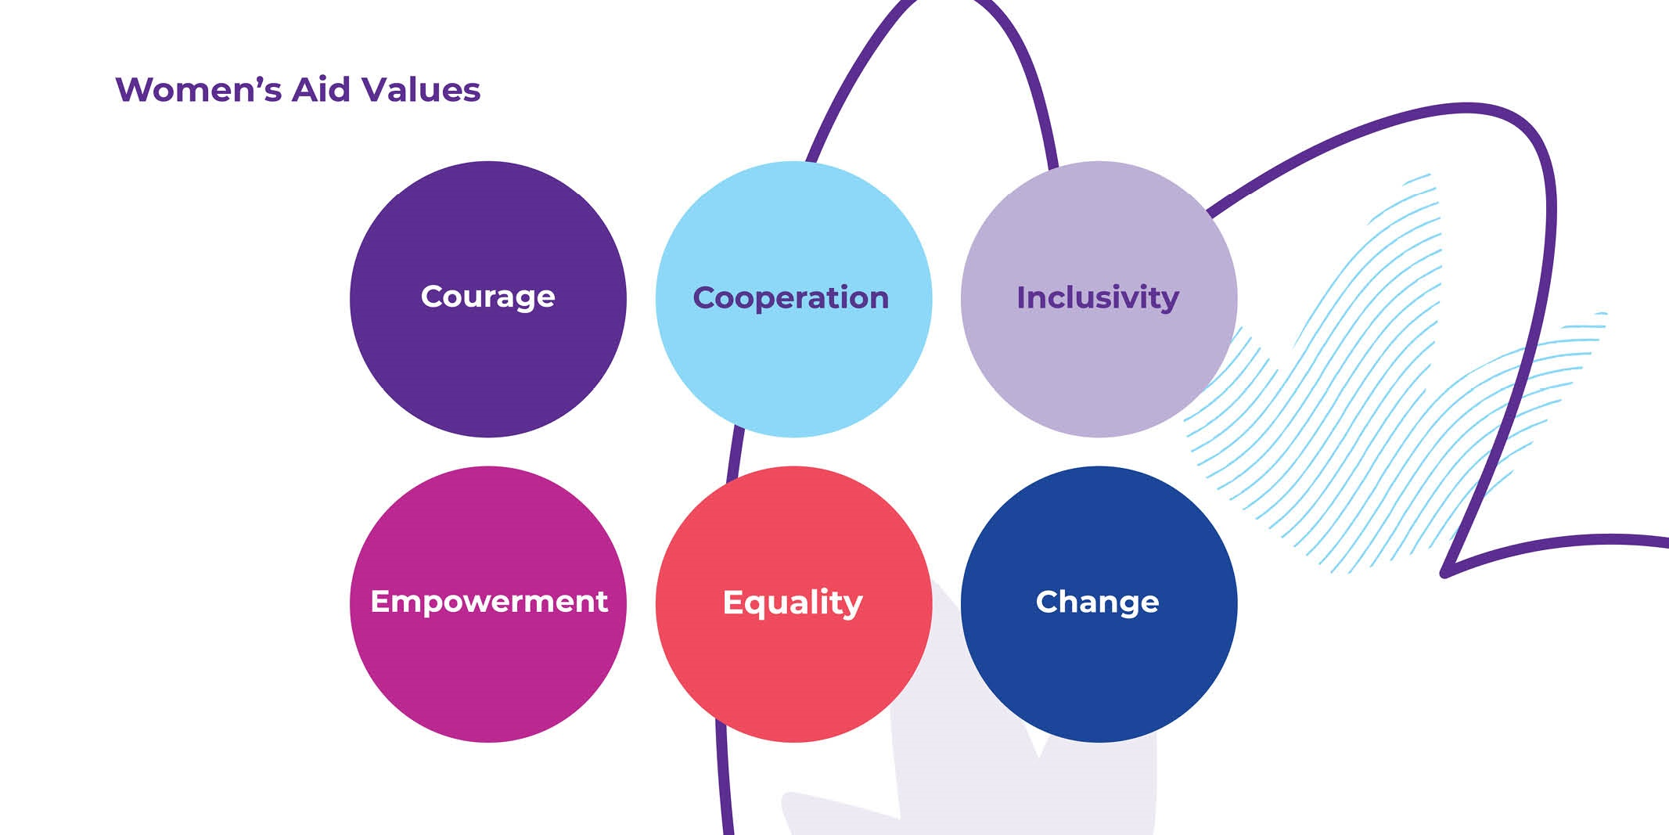

Our vision is an equal Ireland with zero tolerance of all forms of violence against women, including domestic abuse. For more information read our Women’s Aid Statement of Strategy 2022-2024.

About the Training & Development Department
The Training and Development Department has a proven track record of designing and delivering specialist domestic violence and abuse training to local and national organisations throughout Ireland. We support organisations in the statutory, health, community and voluntary sectors, as well as employers, to enhance and improve responses to women who are subjected to domestic violence and abuse. All Women’s Aid training is informed and guided by our decades of experience directly supporting women and by models of best practice.

Employer Engagement Programme
In November 2023 a statutory paid domestic violence leave provision came into force for all workplaces in Ireland. Women’s Aid has led on employer engagement and support for several years, developing our Employer Engagement Programme (EEP) https://www.womensaid.ie/get-training/support-for-employers/ . With this new obligation for employers, Women’s Aid now wishes to enhance our capacity to respond to increased demand for training and support to implement best practice domestic workplace policies.

Training & Development Department Structure
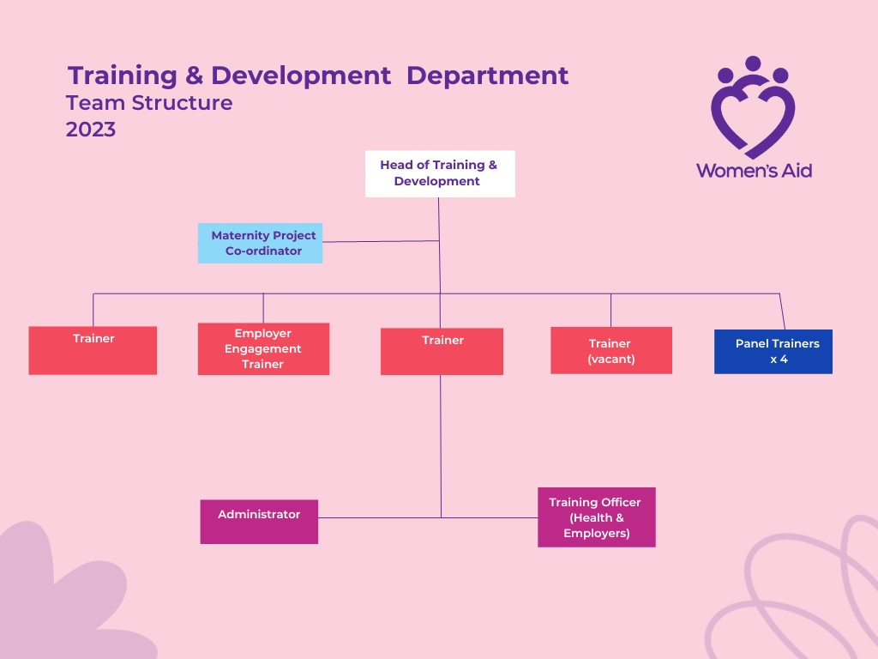

Benefits of Working with Women’s Aid

- Annual Leave: Annual leave entitlement is 25 days per annum pro rata.
- Privilege Days: Good Friday and Christmas Eve.
- Pension: Women’s Aid operates a contributory pension scheme which all employees may join after 6 months in the organisation.
- Maternity Leave: Women's Aid will pay full salary (less Social Welfare benefits) for the period of the 26 weeks paid leave (subject to 1+ year service).
- Parent’s Leave: 7 weeks’ leave topped up to full salary during the first 2 years of a child’s life, or in the case of adoption, within 2 years of the placement of the child with the family for eligible employees.
- Menopause Leave: A policy including paid leave provision is in place for eligible employees.
- Employee Assistance Programme: Women’s Aid provides an extensive employee assistance programme operated by Peninsula.
- VHI: Women’s Aid operates a group VHI scheme which you may join.
- Death in Service Benefit: Available for all employees to the value of 2 years’ salary.
- Health Services Staffs Credit Union: Employees of Women’s Aid may join the Health Services Staffs Credit Union.
- Trade Union Membership: The staff of Women’s Aid has an option of joining the recognised representative Trade Union Forsa.
- Training Allowance: Annual allowance for staff members to undertake training to enhance skills and expertise (subject to budget availability).
- Travel Supports: Bike-to-work schemes and tax saver commuter tickets.
- Equality and Diversity: Women’s Aid is committed to the promotion of equal opportunities and cultural diversity.

About the Trainer (Employer Engagement) Role

Title: Trainer (Employer Support)
Reference: TRAIN24 (please cite in all communications with Women’s Aid).
Reports to: Women’s Aid Head of Training and Development.
Contract: Fixed term Contract – 2 years (24 Months) subject then to review/evaluation.
Hours: Full-time. Women’s Aid’s full-time working week is 35 hours (excluding lunch). Core working hours are ordinarily between 8am and 6pm Monday to Friday, unless a role requires different contracted hours. Flexibility may be required.
Location: Primarily based at Women’s Aid head office in Dublin 2 but also working in an outreach capacity, travelling when appropriate to deliver in person training across Ireland. Some remote/hybrid working may also be required and a % of hybrid working will be considered on application.
Salary: Budget for this post €34,891 - €50,000 (rate commensurate to relevant experience, in line with company remuneration policy). Note: Full Women’s Aid Trainer Pay band: €34,891 - €56,330

Job Description: Trainer (Employer Engagement)

Role objectives:
- As part of the Training & Development team, to design, deliver and promote training and awareness sessions about Domestic Violence and Abuse using in-person, online & blended modes of delivery, to a variety of key stakeholders from groups, agencies, companies and individuals.
- To become proficient in delivery of all of Women’s Aid Core training offers, as part of a small and dynamic team of trainers.
- To facilitate and support agencies and groups to respond appropriately to violence against women and their children by current or former intimate partners.
- In particular for this post, this Trainer will join and collaborate with the Women’s Aid Employer Engagement Trainer and the Head of Training and Development, to engage employers in Ireland for the promotion, design and delivery of training to support internal employee wellbeing initiatives in relation to domestic abuse.
- To grow and develop the Employer Engagement Programme (EEP) for Women’s Aid to reach greater numbers of employers of all sizes, and from all sectors, to implement best practice in implementing paid domestic violence leave and other support provisions to employees subject to domestic abuse.
- To contribute, through skills and experience, to the development of organisational strategies to combat domestic violence in order to effect political, social and cultural change in line with Women’s Aid mission, purpose and values.

Key Responsibilities
- Deliver Women’s Aid training and provide presentations, on understanding and providing best practice responses to domestic violence and abuse, to a wide range of agencies in the community & voluntary, statutory, and corporate sectors.
- Deliver in-house training to Women’s Aid National Helpline Volunteers annually (involves some daytime weekend hours).
- Support agencies and groups to identify their training and development needs and respond professionally to training enquiries.
- Design, deliver and evaluate new training and awareness sessions with the team, and partners when appropriate, geared to the needs of specific groups needs and requirements.
- Review, update and improve existing training with the Team on an ongoing basis to ensure that Women’s Aid training remains up to date and of the highest quality.
- Facilitate agencies and groups to develop good practice policies, procedures and guidelines in relation to combating domestic abuse and responding effectively to victims/survivors of abuse – including for marginalised and minoritized women.
- Participate in the design and development of additional supporting materials for the Department (e.g. leaflets, recorded lectures etc…), with a particular emphasis on employer targeted materials for this role.
- Record all required data on training and other sessions delivered.
- To write reports, and prepare information as required for the Senior Management team, Board or funders as required.
- Collaborate with the Strategic Communications Fundraising Department to ensure clear communications and clarity where training clients including employers may also potentially be charity partners for fundraising purposes.
- Participate in the production of reports and publications compiled by Women’s Aid.

Other Duties:
- Participate in Training & Development Department planning & review sessions and maintain and utilise own work-plans.
- Participate in regular one to one supervision, team, organisational and other meetings where applicable.
- Keep up to date through proactive review of new research, legislation, and training tools/concepts relevant to Women’s Aid training programmes.
- Provide staff training and development where necessary.
- Contribute to the strategic planning of the organization.
- Attend training as requested.
- To participate in multi-disciplinary groups and with local agencies in an awareness raising and influencing capacity if required.
- Present the work of the Women’s Aid Training & Development Team in external information sharing forums.
- To carry out all other duties as required, commensurate with the responsibility of the post.
- To abide always by the philosophy, values and ethos of Women’s Aid.

Experience and skills sought.
The ideal candidate will have the following experience and competencies:

Essential experience and competencies:
- A qualification in a field of relevant academic training (NFQ/QQI level 7 or higher).
- A minimum of three years training/facilitation experience.
- A feminist (gendered) analysis of domestic Violence, and a strong commitment to eliminating all forms of violence against women & girls.
- Direct experience of designing & delivering training content with clear aims, objectives and outcomes for a Community & Voluntary, frontline statutory or other relevant audience.
- Have excellent interpersonal, written, and verbal communication skills.
- Excellent administrative & IT skills (all Office packages, Record keeping, data collation)
- Detailed knowledge of the dynamics of domestic abuse, including Coercive Control.
- A high level of professionalism, integrity and personal accountability, when engaging with diverse stakeholders.
- Demonstrable time management skills, and ability to work highly effectively on own initiative.
- Results and solutions driven.
- Enthusiastic, warm and friendly manner.

Desirable experience and competencies:
- Experience in design and delivery of interactive training and e-learning using online platforms (e.g. Zoom) an advantage.
- Experience of working directly with women in a support/advocacy role.
- Knowledge and experience of training design and delivery to private & public companies an advantage.
- Experience of effective project planning and evaluation.
- Experience working co-operatively with other services, and in relationship building and maintenance.
- High level of competency working with Microsoft Office, including Outlook, Teams, Forms & SharePoint.
- Up to date knowledge and experience of child protection issues including Children First.
- Knowledge of intersectional factors impacting help seeking for marginalised and minoritized communities.
- A full clean driving license and access to own vehicle.

How to Apply

Application Form: completed application forms, clearly referenced TRAIN24 in the subject line, should be sent by email only to Deborah Warren, Training Administrator, email deborah.warren@womensaid.ie

CVs will not be considered.

Closing date: 5pm, Monday 13th May 2024.

Interview schedule: It is anticipated that first round interviews will be held Thursday 30th May 2024.

